Oatlands Golf Club SCC application
Site Map
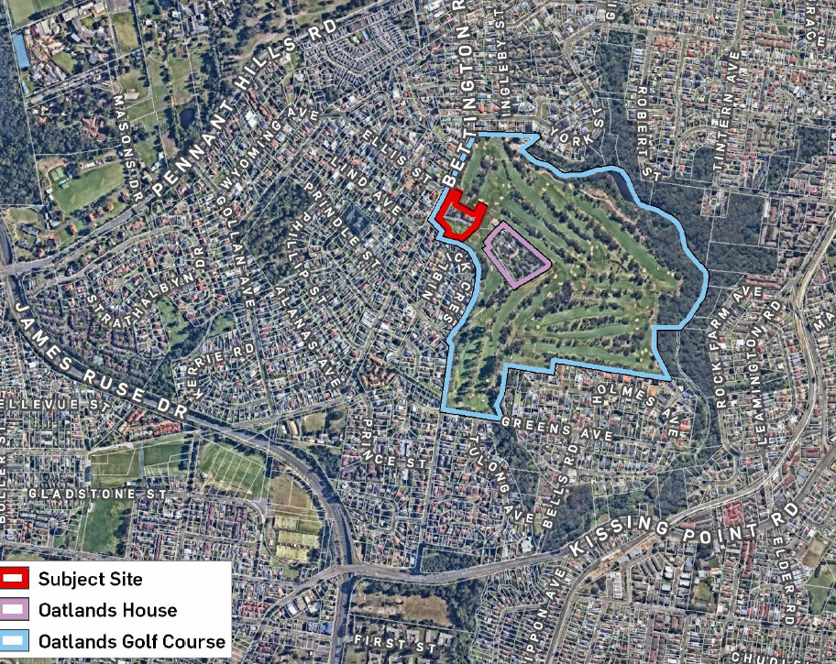
Figure 1: Map showing the Oatlands Golf Course and the proposed seniors housing development site (Source: Urbis)
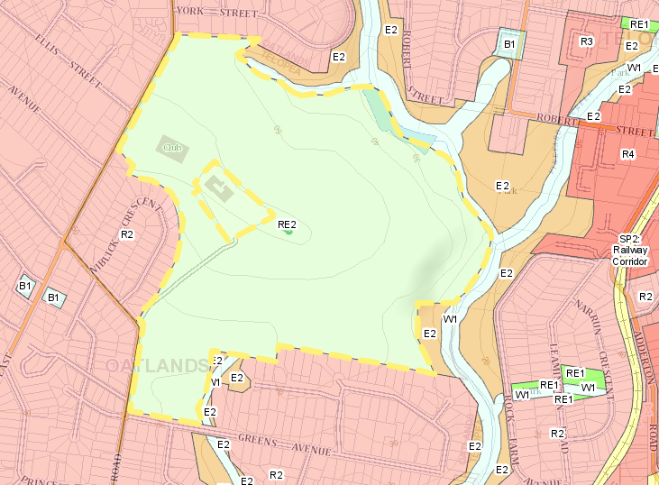
Figure 2: Map showing the Oatlands Golf Course (yellow border) and surrounding development (Source: ePlanning Spatial Viewer)

